In normal way, we can access to CloudD in this way.
- Access to http://clouddvh.lgdisplay.com/vmCube/Login
- Fill in username and password
- Click
Certainly some applications need to be installed to access Cloud PC.
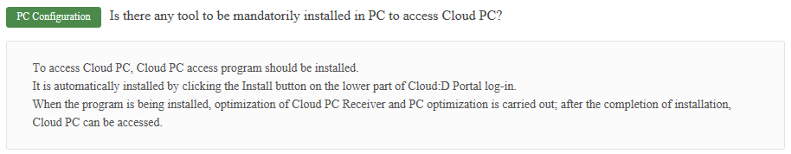

If we use VMware Horizon Client and fill in connection server (gcloudvcs.lgdisplay.com) then username and password to login we can still access to Cloud PC.
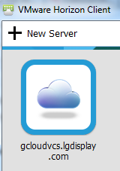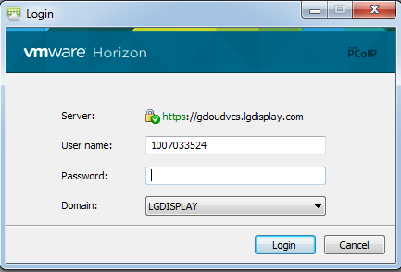

From my opinion, if someone with laptop can connect to connection server and use Cloud PC in this way, it can cause data leakage because they don’t need required softwares (to prevent data leakage) to use Cloud PC.
I use my laptop with required software so my opinion maybe wrong. I don’t have test environment to test whether it’s security issue or not.

